**IST 659 Project Deliverable**

**Summary:**

Since I was a young kid, my dad has always been a big fan of the NFL. He is such a big fan that every year he makes the whole family pick the winners for each game. Each week he lists all of the games and we have to pick a winner as you can see in the picture below. Then, at the end of the season he tallies all of our correct picks and one of the four of us is crowned the winner. He has data like this for the past 10 years in an excel file where he also keeps a bunch of statistics. I eventually want to create a web application where we can keep track of all of our picks and the games’ scores. This will require a well-made Relational Database that includes the divisions of the teams, scores, and will be able to calculate playoff contenders by itself. Then, I would also like to post simple statistics like which team is my most accurate pick each year or throughout the whole lifetime.

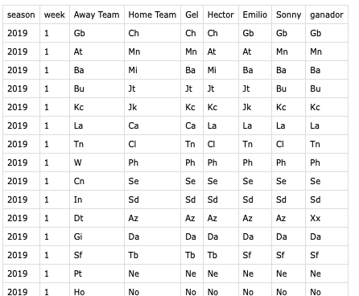

**Conceptual Model:**

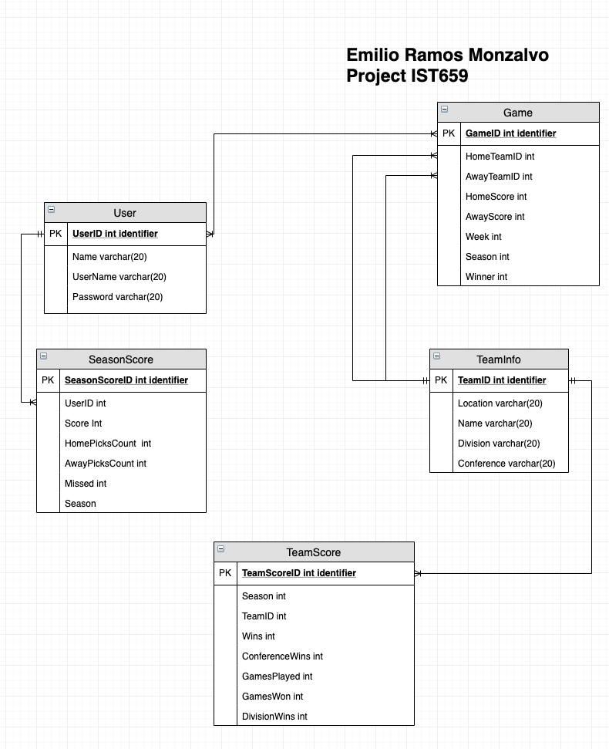

Glossary:

* User: Used for login and user information
  + UserID: identifier for users
  + Name:
  + username: used for login information
  + Password: used for login information
* SeasonScore: used to keep trak of the users statistics on how many games he has predicted correctly
  + seasonScoreID: Unique identifier for the entity
  + UserID: used to check who’s score this is
  + Score: How many the user has gotten correct
  + HomePicksCount: How many teams he has that were playing a home
  + AwayPicksCount: How many teams he has that were playing away
  + Missed: How many games he has predicted incorrectly
  + Season: What season we are on
* Game: Keeps track of the teams schedule throughout the season
  + gameID: Unique identifier for the entity
  + HomeTeamID
  + AwayTeamID
  + HomeTeamScore
  + AwayTeamScore
  + Week: what week is the game on
  + Season: what season is the game on
  + Winner: who won the game
* TeamInfo: Used to keep track of the teams conference and division for playoff calculations
  + teamID: Unique identifier for the entity
  + Location
  + Name
  + Division
  + Conference
* TeamScore: Used to keep track how a team is doing in season
  + TeamScoreID: unique identifier for the entity
  + teamID: unique team id
  + season: Unique year in which the score is reflected on
  + GamesWon
  + GamesPlayed
  + ConferenceWins
  + DivisionWins

**Normalized Model:**

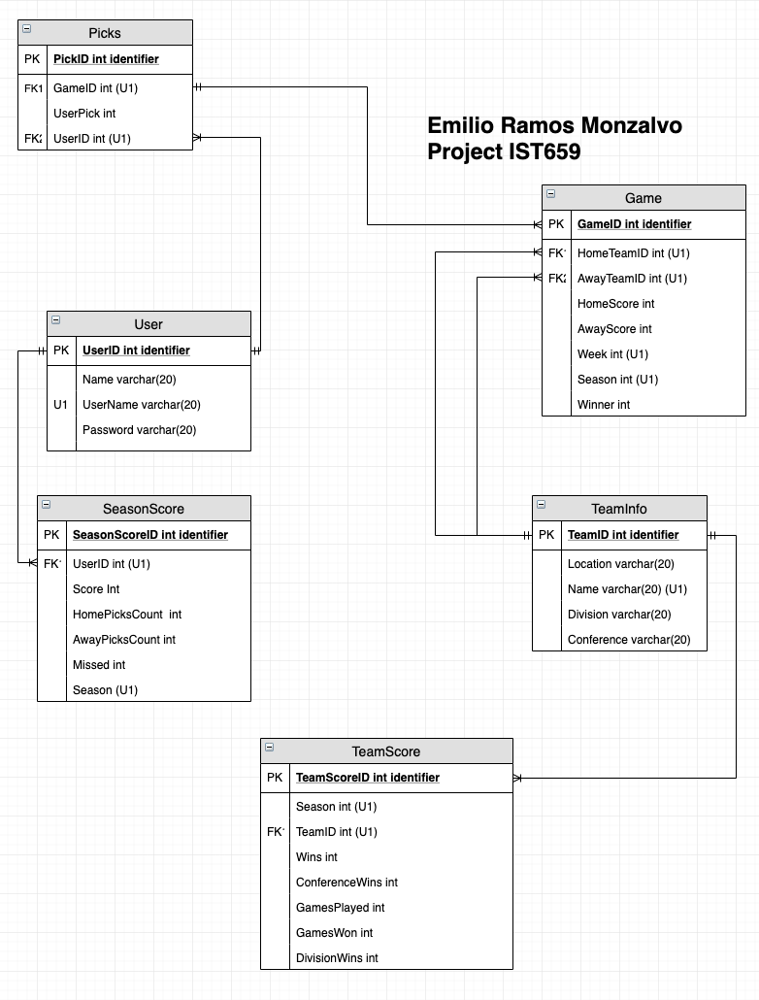

I added the picks entity in order to get rid of the many-to-many relationship between the Game and User entity. This way it is much easier to track which user picked what team in each game.